Teledermatology Patient Handout

What is teledermatology?

Teledermatology is a form of telehealth that allows you to access the care of a dermatologist remotely through your smartphone, computer or tablet. Teledermatology can be used whether or not your child has seen a dermatologist before.

There are three main types of teledermatology:

- Video visits: Live interactive teledermatology allows you to video-chat with a dermatologist. During this conversation, you can discuss your concerns in real time. The dermatologist will usually ask that photographs of the skin condition are submitted to be reviewed prior to the video visit. The dermatologist then provides you with recommendations and can prescribe treatments if needed. The advantage of live interactive teledermatology is that you can ask questions and receive feedback right away. You will need a fast internet connection and a smart device equipped with a camera and microphone. You should also be in a private room where you can comfortably show the dermatologist any affected skin areas and be close to a wireless router. Download and test the app ahead of time to ensure it is working prior to your appointment.
- Messaging between your provider and a dermatologist: This is when your primary care provider or another doctor provides the dermatologist with your child’s information and photos. The dermatologist then provides recommendations to your doctor who interprets them and communicates them to you.
- Messaging between you and your dermatologist: This form of teledermatology allows you to securely upload photos of the affected skin area to your dermatologist using a smartphone app or computer software. You should include a description of what has been bothering your child (e.g. When did it start? Is it itchy?) and any questions you have. The dermatologist then reviews your photos and questions and electronically provides you with information on what to do next.

NOTE: Teledermatology is not available everywhere. Please ask your medical provider to learn more about the details of cost, turnaround time and rules related to teledermatology options in your area, as well as the specific platforms that are available.

What are other advantages of teledermatology?

- Cost-effective
- Reduces wait time
- Eliminates travel time and costs
- Requires little or no time off from work or school to access a dermatologist

What are some limitations to teledermatology?

- Not suitable for a full body skin screening or full “skin check”
- May not be able to diagnose or treat certain skin conditions that require a hands-on examination such as deeper lumps or bumps
- May not be able to diagnose or treat skin conditions that are difficult to photograph such as some on the scalp, in the mouth or on the genitals.

How do I take high-quality photos on my smartphone?

Taking high-quality photos on your smartphone is an essential part of teledermatology and can be as easy as 1, 2, 3.

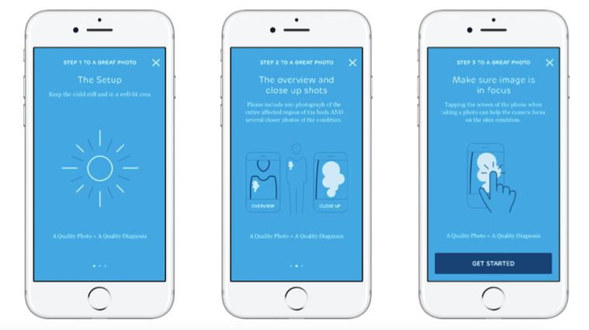
1 2 3

Other tips for taking high-quality photos:

- Do not use the zoom feature or “selfie” camera on your smart device.
- Turn off the flash.
- Take photos in a well-lit area with bright white lighting. (When possible, natural sunlight near a window or even outside is best.)
- Avoid shadows in photos.
- Use a solid background.
- Close-up photos should be taken approximately six inches away from the skin.
- Place a coin next to the affected area for scale.

For more information on teledermatology, contact your healthcare provider or please visit: https://www.aad.org/public/fad/telemedicine

