NEVUS SIMPLEX

What Is Nevus Simplex?

Nevus simplex, also called a "salmon patch" or "stork bite," is a special mark that some babies are born with. It is very common and doesn't hurt.

What Does Nevus Simplex Look Like?

Nevus simplex birthmarks are usually pink or red patches on the skin. These birthmarks are there when a baby is born. They are common on the baby's forehead and upper eyelids. They can also be on the back of the head, the upper lip, or the back. They might look darker and more noticeable when babies are upset or crying.

Nevus simplex birthmarks are flat. They do not grow or thicken with time. They are most commonly pink or red. In darker skin tones, nevus simplex might not be as easy to see, but they still look pink or red.

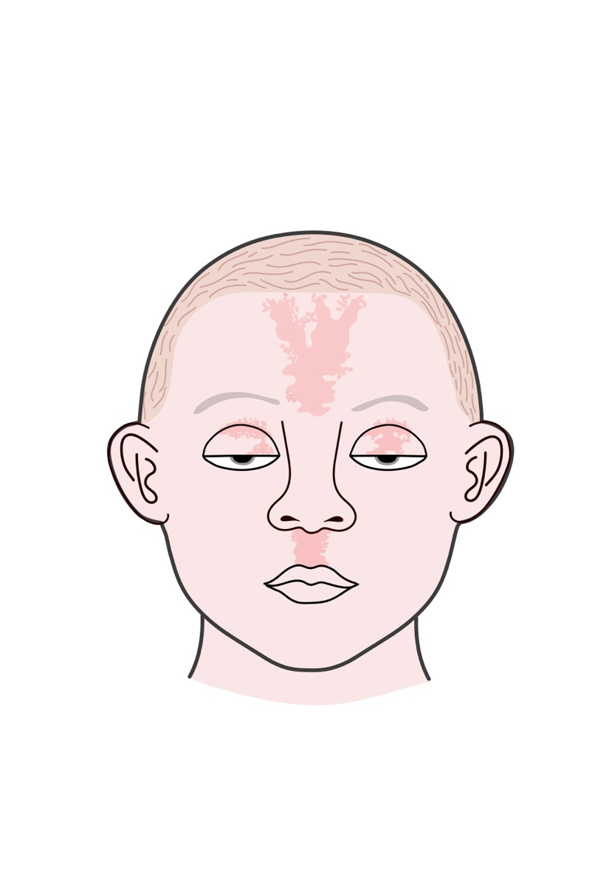 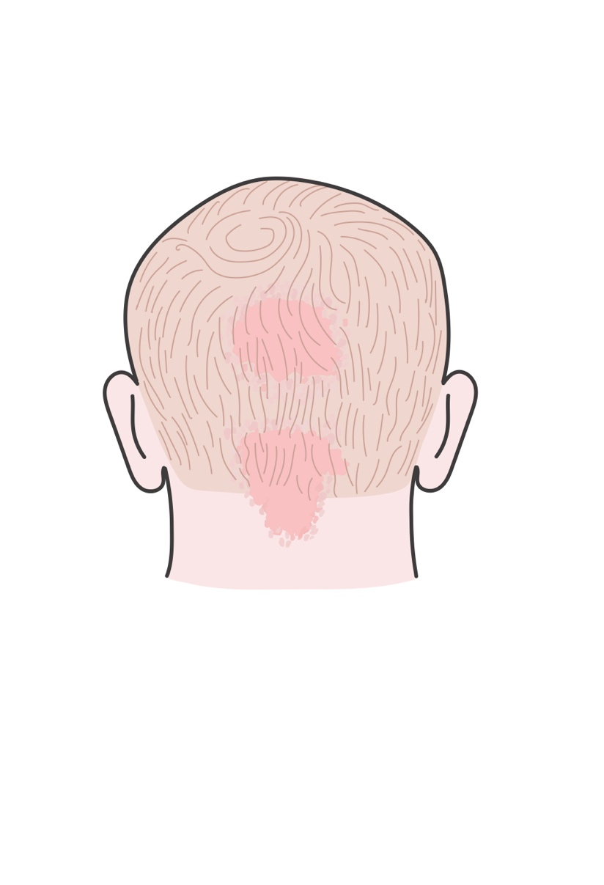

How Do Doctors Know It's Nevus Simplex?

Usually, doctors can recognize a nevus simplex just by looking at it. They usually don't need any tests. Sometimes, doctors might ask about the baby's health history to confirm the diagnosis. Most of the time, babies with nevus simplex are perfectly healthy.

Can Nevus Simplex Get Better? Is Treatment Ever Needed?

The good news is that nevus simplex usually fades and goes away on its own, usually by age 12 to 18 months. Treatment is usually not needed. For a few years after nevus simplex fades, it may show up again when children are upset and crying.

Sometimes, nevus simplex does not fade completely. Usually this happens on the neck and in the scalp. The hair can hide this so treatment isn’t needed.

If the nevus simplex on the face is still very easy to see when your baby is one year old, talk to your doctor about possible treatment. Laser treatments can be very effective if the birthmark doesn't fade by itself.

Do Babies with Nevus Simplex Need Extra Checkups?

Once your doctor has confirmed it is nevus simplex without any worries, most babies with nevus simplex don't need extra checkups. You and your pediatrician can watch the birthmark over time to make sure it is not growing. Instead, you should see it getting lighter over time.

Authors: Ilona J. Frieden M.D. and Mary Larijani M.D.  
Reviewers: Sarah D. Cipriano, MD, MPH, MS; Keith Morley, MD